

Train Tickets Dispenser
  - Digital System Design Lab Project

group: 30411
STUDENT: Știube Bogdan - Antonio
Coord. Prof. Pop Diana - Irena

TABLE OF CONTENTS

CHAPTER 1: PROJECT SPECIFICATIONS……………… 3
1.1 Operating Procedure...…………………………………………. 3
CHAPTER 2: DESIGN…………………………………….…. 4
2.1 The Black Box ...………………………………………………. 4
2.2 Command and Execution Units………………………………... 5
2.2.1 Mapping the inputs and outputs of the C.U. and E.U. …………... 5
2.2.2 Establishing the Resources (E.U.) ………………………………. 6
2.2.3 Block Diagram …………………………………………………. 12
2.3 State Diagram of the Control Unit …………………………… 13
2.4 Detailed Diagram …………………………………………….. 15
CHAPTER 3: USER MANUAL……………………………... 20
CHAPTER 4: DESIGN SOLUTIONS JUSTIFICATION…. 20
CHAPTER 5: FURTHER DEVELOPMENT.……………… 21
CHAPTER 6: BIBLIOGRAPHY……………………………. 21

CHAPTER 1: PROJECT SPECIFICATIONS

Design a train ticket dispenser in which the user inputs the distance the wishes to travel (in tens of kms). The cost of the ticket is displayed on the SSD. The dispenser receives the necessary sum of money and issues a ticket alongside with the change if it is the case. The cases in which there are no tickets left, the inputted sum is less than the cost or there are not enough money for the rest will be signaled by a lit led.

Operating Procedure

- Initial state: the dispenser is in “Standby” mode until the “START” button is pressed

- Check for tickets: immediately after the “START” button is pressed, it will be checked if there are no tickets in the dispenser. If that is the case, the “NO TICKETS” led will be lit, the operation aborted and the automaton will return in its initial state

- Input distance: if there are tickets in the dispenser, then the dispenser will require from the user the distance he wishes to travel. Once done, he presses “CONFIRM” to progress

- Cost display: the cost of the tickets is displayed to the user. He will need once again to press “CONFIRM” to go to the next step

- Input cash: the user inputs the cash necessary to buy the ticket. For as long as the sum will be lower than the cost, the “NO CASH” led will be lit and as soon as the cost is met it will be shut down and the cash inputs will be locked. He will have to press “CONFIRM” once more

- Cash-Cost Comparison and Give Change/Cash Back: the inputted money and the cost will be compared: if the two are equal a ticket is issued. If the cash is greater than the cost, if possible, the change will be given to the user, if not, the “NO REST” led will be lit and the cash will be restituted in its entirety back to the user.

- Internal money update: the money that are in the dispenser will get updated relative to the cash that the user inputted and the change that was given to him

- Tickets issue: a led will be lit signaling that a ticket has been issued and the dispenser will return back to “Standby” mode.

“Guiding light” feature

The user will be guided by a specific led indicating the step that he is currently on in the process of buying a ticket.

CHAPTER 2: DESIGN

The Black Box

CLK
EN10

EN20

EN5

EN50

EN2

EN1

ENH

ENT

CONF
RST

START

TRAIN TICKET DISPENSER
7
4
AN
SEG

NR

TCKT

NC
s
NT

S0 S1 S2 S3 S4 S5 S6

Command and Executions Units

Mapping the inputs and outputs of the C.U. and E.U.

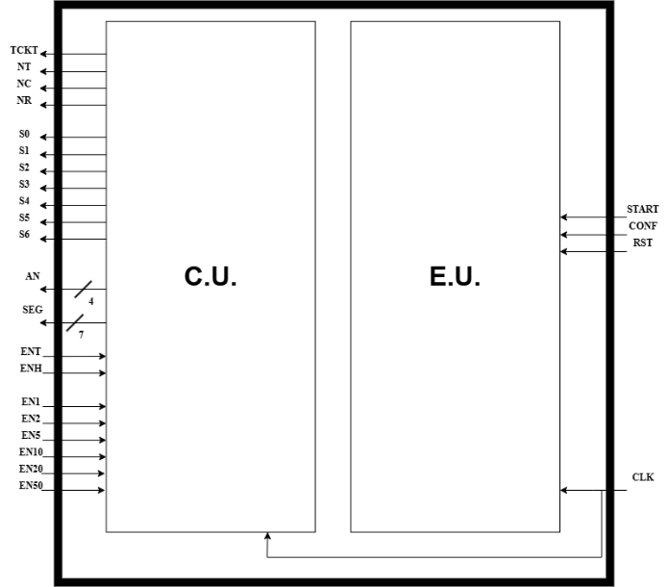

2.2.2 Establishing the resources (E.U.)

- Frequency Divider

This purpose of this circuit is to slow down the 100MHz clock of the fpga to about 1Hz. It is used in the Distance Counter and Input Bill Counter so the distance and money can be seen clearly by the user whilst they are gradually updating, to match the desired input.
CLK_FAST
CLK_SLOW
FREQUENCY DIVIDER

- Frequency Divider CU

The purpose of this frequency divider is the same as the one before with the: to slow down the high frequency clock, but this time, its value is divided by 2¹⁰ and is meant as input for the CU. This way, the other operations that run on the 100MHz frequency have enough time to finish and the clock of the CU is still fast enough so the user can’t notice any slowdown in the functioning of the automata.
FREQUENCY DIVIDER
CLK_FAST
CLK_SLOW
CLK_FAST
CLK_SLOW

- Button Debouncer

The button debouncer is a circuit that takes the signal generated by the button press on the fpga and corrects any slight changes of value by generating a single pulse with a period of the input clock. It is essential to avoid any unpredictable behavior of the automata.
BTN_DB
CLK_100
BTN
BUTTON DEBOUNCER

- Binary Digit to Cathode Converter

As the name suggests, this converter is made to transform a 4-bit binary number to its equivalent representation on the cathodes of a seven-segment display. It can covert only digits from 0 to 9 decimal which are further passed to the actual display.
NR – CAT CONVERT
NR
4
7
CAT

- Integer Digit to Cathode Converter

It won’t be wrong to assume that this circuit does the same operation as the one from above because it actually does so, but with a key difference. Instead of converting 4-bit binary numbers to their cathode representation, it converts integers: digits from 0 to 9, which are passed in the same way to the display.
CAT
INT
7
INT – CAT CONVERT

- Three Digit Seven Segment Display
This circuit is the one that actually does the display of three different digits. The fpga is built in such a way that all the anodes are connected to the same bus. Because of this fact there were some tricks that had to be done in order for it to display distinct numbers: have the digits switch at a high enough frequency on the display so that the eye can’t detect the actual switching, but still see different digits. This was done with an additional clock divider as well as a multiplexor.
DIGI1
7
7
7
4
7
SEG
AN
CLK
DIGI3
DIGI2
THREE DIGIT SSD

- Distance Counter (x2)

Two instances of this counter are used inside this automaton. They are used by the user to introduce the distance he wishes to travel. By the way they are designed, the maximum distance an individual can input is 990 kms since the counters modify only the hundreds and tens while the units remain 0. They start counting when the enable for each respective counter is turned on by the user. The HOUT and TOUT along with the 0 digit on the units make out the DIST (distance), an integer further used in the EU.

TOUT
ENT
RST
CLK
4
TENS COUNTER

HOUT
RST
CLK
ENH
4
HUNDREDS COUNTER

- Input Bill Counter (x6)

The purpose of these counters is for the user to be able to input the money into the train ticket dispenser. Six of them are used since are the six types of bills: 1€, 2€, 5€, 10€, 20€ and 50€. For each such counter there is also an enable which the user may turn on. Multiple enables can be turned on at once, but once the introduced sum is greater or equal to the cost, these inputs will be locked.
CLK
RST
ENX
X_BILL_COUNT
4
X€ BILL COUNTER
X in {1, 2, 5, 10, 20 ,50}

- Internal Bill Counter (x6)

These counters are meant to keep track of the money that is inside the dispenser at once. It has two inputs which are commanded internally by the Internal Bill Updater: an enable for count-up and one for count-down. This way they can easily be updated according to the inputted money and given change. Also, the content of these six counters (one for each type of bill) are checked inside the Change Algorithm as they compose the MONEY_VECTOR to see which bills are available to give as rest to the user.

CLK
EDX
EUX
NR_X_BILLS
8
X€ INTERN BILL COUNTER
X in {1, 2, 5, 10, 20 ,50}

- Ticket Manager

This particular counter has the job to keep track of the number of tickets that are inside the dispenser at one time. When no tickets are available the NT signal is passed to the CU, otherwise the ticket buying operation will continue. At the end of the whole process, a count-down is commanded by the CU to this counter so the tickets decrease by 1. The ticket manager, internally, contains a counter on 8 bits and a comparator which compares the number of tickets with 0, thus generating the NT signal.

NT
ENX
CLK
TICKET MANAGER

- Cost Computation Algorithm

The obtain the cost of a ticket, the distance is multiplied by 0.4 and the output is the cost, which is then displayed to the user.
DIST
COST
COST COMPUTATION

- Cash – Cost Comparator

This comparator has one simple job: to compare the inputted CASH (which was previously transformed to an integer) to the COST. For as long as the CASH is less than the COST the CU will signal it to the user with the NO CASH (NC) led. Once the cost is met, a signal is passed to the input bill counters which locks them.

LOCK (CASH >= COST)
EQ
COST
CASH
CASH – COST COMPARATOR

- Change Algorithm

As the name says, this sequential circuit has the purpose of computing the change that has to be given back to the user if he introduced more money than the cost. It has multiple inputs them being: COST and CASH (integers) as well as amount of each type of bill that are inside the automata. This was implemented with a Finite State Machine (FSM) that runs a Greedy type algorithm.

The way it works: it tries to add to the COST each type of bill starting from the largest. If it can’t add a bill because it exceeds the CASH or there aren’t any then it skips to the next smallest bill. If the COST doesn’t reach CASH, then the rest can’t be given, this being signaled by the CU with the NO REST (NR) led.

MONEY_VECTOR
24
48
REST_VECTOR
NR
COST
CASH
CLK
CHANGE ALGORITHM

- Money Updater

This circuit commands the count-down and count-up of the Internal Bill Counters by deciding at each step which of the enables are set. This is done for as long as the vectors representing the rest and cash are different from 0. If both are 0 then an UPDATE_DONE signal is passed to the CU meaning that the update finished, the automata going back to the idle state.

24
24
EDX
EUX
UPDATE_DONE
REST_VECTOR
CASH_VECTOR
CLK
MONEY UPDATER
X in {1, 2, 5, 10, 20 ,50}

Block Diagram
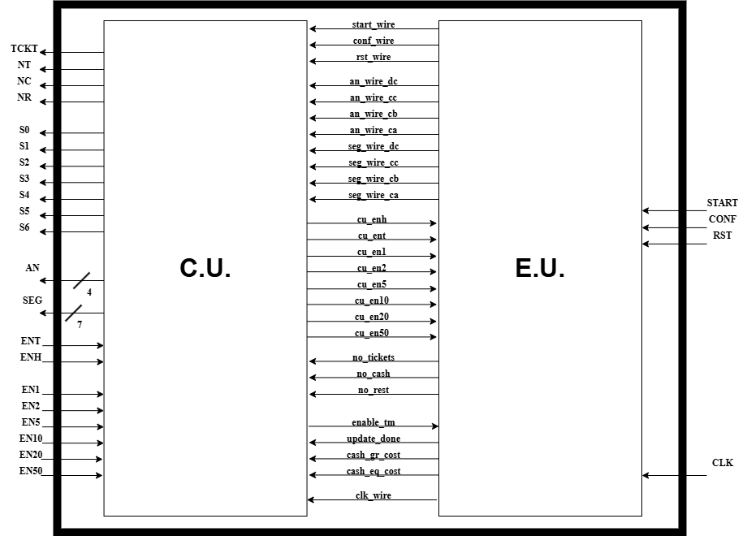

State Diagram of the Control Unit
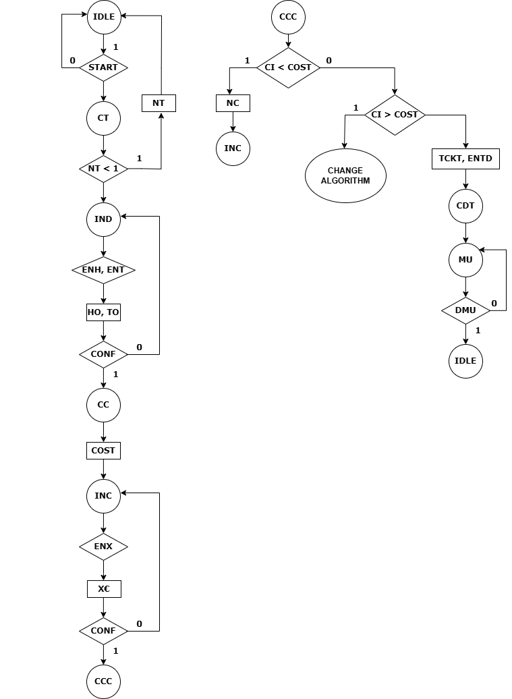
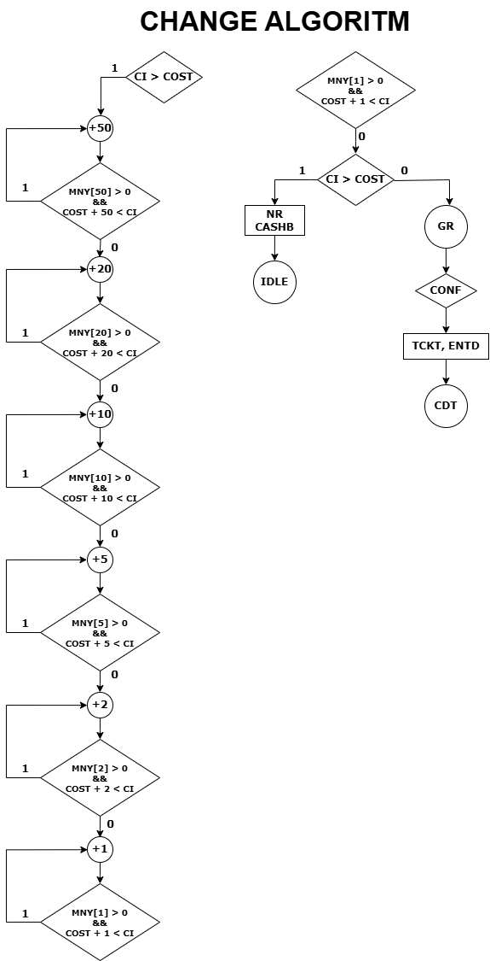

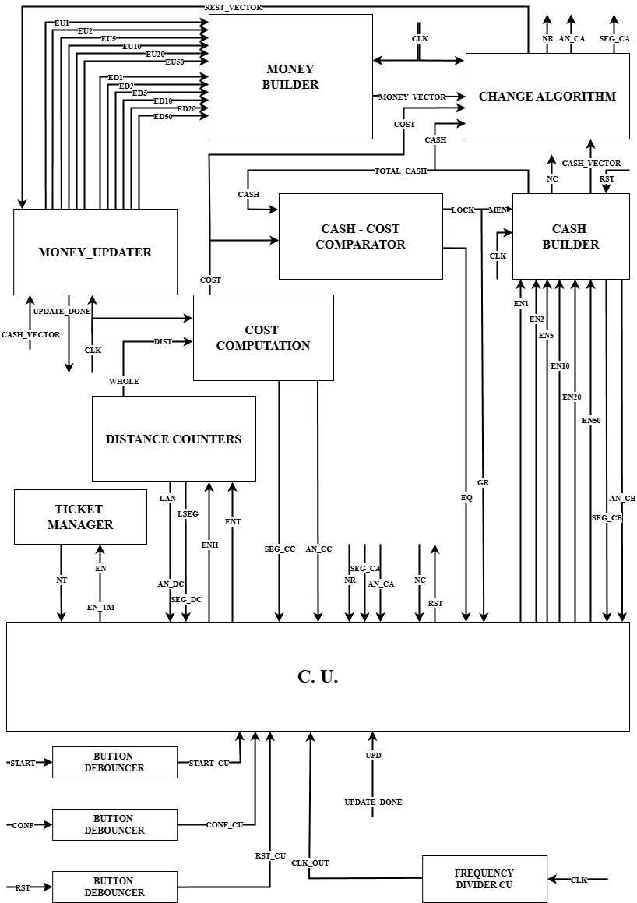
Detailed Diagram

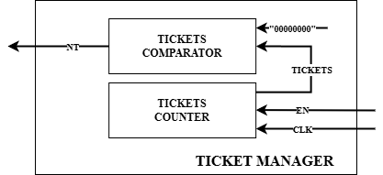
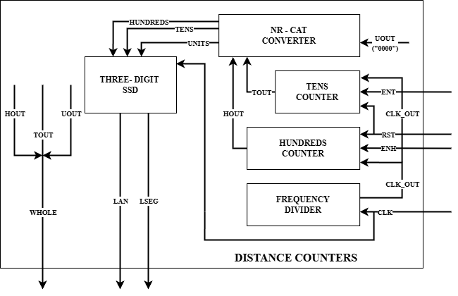
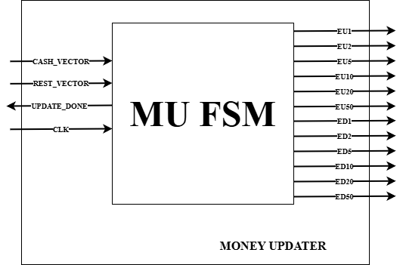
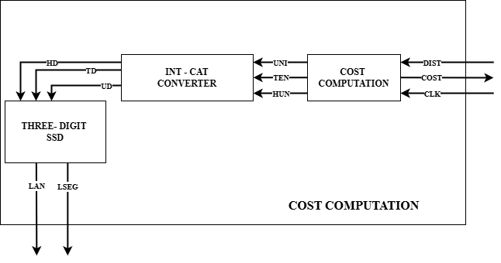
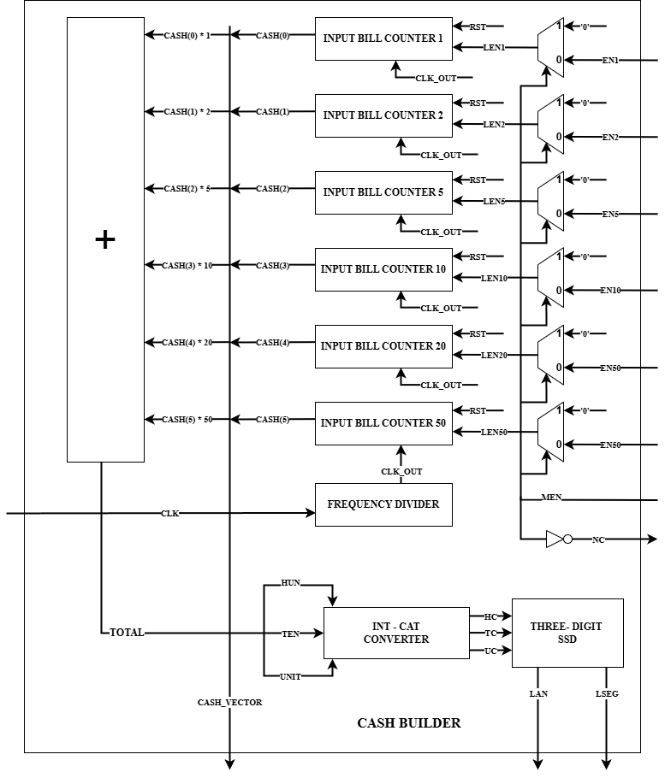
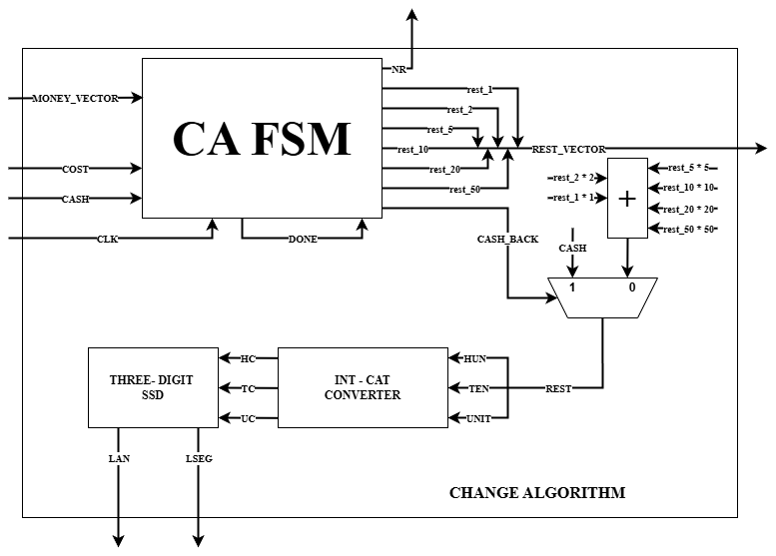

CHAPTER 3: USER MANUAL

There are multiple steps to buying a ticket using the dispenser so here will be detailed each one of them:
- If the first led from left to right is lit: press “START” to begin.
- If the second led from right to left is lit: tickets are not available, the dispenser will return back to its initial state.
- If the third led from left to right is lit: input distance you wish to travel and press “CONFIRM” once done.
- If the fourth led form left to right is lit: the cost is displayed; press “CONFIRM” to proceed to the next step.
- If the fifth led from left to right is lit: input the cash to buy the ticket. The third led from right to left will stay lit for as long as the inputted cash is less than the cost. Once the cost is met, the cash inputs will be locked. Press “CONFIRM” to progress.
- If the sixth led from left to right is lit: if possible and it is the case, change will be given. Press “CONFIRM” once more. If not possible, the fourth led from right to left will be lit: the cash that was inputted before will be restituted and the dispenser will return back to its initial state.
- If the first led from right to left is lit: a ticket has been issued.

CHAPTER 4: DESIGN SOLUTIONS JUSTIFICATION

The overall design of the automaton was made with the idea of it being both user friendly and highly efficient regarding its internal operations.
With this thought in mind the handling of internal values (tickets and money) was made with counters (normal and bidirectional) since it is easy to update them using an enable at the right moment. Another option would have been to use registers, which surely would have also worked, but the update of each value would have taken more operations (subtract/add from the initial value, enable load, load) alongside being more difficult to keep track of each signal throughout the system.
Another design choice was locking the cash inputs immediately after the cost is met. The logic is simple: after enough money to buy the ticket have been introduced, why introduce more? Not using this feature could have also increase the risk of being unable to give change to the user further down the line.

CHAPTER 5: FURTHER DEVELOPMENT

In terms of what could be done for further development of this train ticked dispenser, multiple things could be implemented.
One of them could be the option of buying multiple tickets at once. Another would be that the user could return the ticket and have his money back under certain criteria. Since the tickets are a bit pricy, one could select the social category he is in, like student, elder or disabled person, and get a discount based on that.
Another obvious change would be to increase the capacity of each counter, so it can hold more tickets and money so that the management team won’t refill it as often.
A harder thing to do would be to implement a system where the user could select the type of currency he uses, not only euro (ex. RON, USD, JPY, etc.) and, if it is the case, he would also receive the change in the selected currency. This would require to multiply the internal bill registers so it can hold the multiple values of each type of currency.
Internally, there could be a more efficient CHANGE ALGORITHM, that is still a greedy one, this being, find the change that must be given: CASH – COST and instead of the iterative subtraction that is done, in each state a division would be made by the value of each type of bill. The quotient would be the bills that could be given back and the remainder would be passed further on to be divided by the value of the next bill. If at the end of the execution the remainder becomes zero then change can be given and no change can be given, otherwise. Also, the checking for the amount of bills that are available internally should be updated accordingly, as well as the incrementation of the change of that specific type of bill.

CHAPTER 6: BIBLIOGRAPHY

- Courses and laboratory session for LD and DSD from the first and second semester
- VHDL code for debouncing buttons on FPGA - FPGA4student.com
- How to assign each digit of a number on the chosen seven segment display ? (Nexys 4DDR) - FPGA - Digilent Forum
- [FPGA Tutorial] Seven-Segment LED Display on Basys 3 FPGA - FPGA4student.com

